Lab 1 – 1st Iteration
Project: Amplio - Collaborative Music Playlist Platform
New feature: Friend System
Team: Vilkai

1. Context

1.1 Business Description
Amplio is a collaborative music playlist management platform that enables users to create, share, and participate in live music sessions. The platform allows users to create public or private playlists, invite others to join sessions via generated keys, collaboratively add songs, and vote on the playback order.

1.2 Current System Boundaries
Current Features:
- User authentication (registration, login)
- Playlist creation and management (public/private)
- Song search and addition to playlists
- Collaborative voting on songs
- Live session management (play/pause, next/previous)
- Leaderboards for popular playlists and albums
- Join playlists via generated keys
Current Actors:
- Registered Users
- Playlist Hosts
- Playlist Participants

1.3 Business Context and Motivation
Currently, users must manually share playlist join codes to invite specific people to their music sessions. There is no way to maintain persistent social connections within the platform. Users cannot easily:
- Find and connect with people they frequently listen to music with
- View their friends' public playlists
- Quickly invite friends to new sessions
- See what music sessions their friends are currently in
The friend system will address these limitations by introducing persistent social relationships, making the platform more engaging and reducing friction in the collaborative music listening experience. While platforms like Spotify and Apple Music offer basic social features such as shared playlists and friend activity feeds, they lack real-time collaborative control and live session management. Their social features are locked behind paid subscription tiers. Discord music bots provide session-sharing capabilities but require external setup and offer no persistent playlist or social infrastructure. Amplio bridges this gap by combining live collaborative listening with a native social layer, accessible without a paywall.

1.4 Customers and Partners
Primary Customers
- Social Music Listeners – users who regularly listen to music with friends. The friend system increases their engagement and time spent on the platform.
- Event Organizers – host recurring music sessions. The friend system eliminates the need to share join codes with the same people every time.
- Music Enthusiasts – want to discover new music through their social network. The friend system allows them to see what others are listening to.
Partners
- Music Data Providers (Spotify API, MusicBrainz) – supply songs and metadata. A growing user base increases their reach as well.
Secondary Stakeholders
- Investors – interested in daily active users growth, lower churn rate, and longer sessions driven by social features.
- Competitors (Spotify, Apple Music) – their existing social features create competitive pressure; the friend system is a direct response to this.
- Privacy Regulators (GDPR) – the friend system collects social connection data, requiring proper user data control in line with EU regulations.
- Platform Administrators – moderate the platform and handle potential conflicts between users.
Business Value
- The friend system increases user return frequency, encourages organic growth through recommendations, and strengthens platform differentiation from competitors.

1.5 SWOT Analysis
- Strengths - Strong core. Real-time collaborative listening with voting and session control sets Amplio apart. Solid existing feature set and free access give it an edge over paywalled competitors.
- Weaknesses - No persistent social layer yet, and manual join codes create friction. Customer base is fairly niche, limiting mass-market appeal.
- Opportunities - The friend system unlocks natural follow-on features like activity feeds and quick invites, which could significantly boost engagement and retention. Free positioning attracts users tired of subscription costs.
- Threats - Spotify and Apple Music could expand collaborative features at any time. Discord already has strong existing social graphs. Avoiding subscriptions or any other paid methods raises long-term sustainability concerns.

2. Stakeholders and Their Needs

2.1 Registered Users
ID: ST-USER
Description: Any authenticated user of the platform
Needs:
Need ID | Description | Priority | Rationale
N-USER-01 | Feel connected to friends through music | High | Humans have fundamental need for belonging and maintaining social bonds
N-USER-02 | Control who becomes part of their social circle | High | Control over social connections, ability to accept or decline them
N-USER-03 | View their friends and their communities | High | Seeing your friends and community provides sense of identity and belonging
N-USER-04 | Unfriend other users and leave communities | Medium | Manage unwanted connections
N-USER-05 | View friends public playlists and discover what they like | Medium | Discovering what your friends and connections listen to is more relevant than algorithmic recommendations
N-USER-06 | See which friends are currently online/in sessions | Medium | Ability to join friends that are listening to music is a way to build meaningful connections and create experiences together
N-USER-07 | Search for users by their identifiers like name and etc. | High | Find your friends on the platform, or find new people
N-USER-08 | View pending friend requests | High | Manage incoming requests
N-USER-09 | Cancel sent friend requests | Low | Social grace requires ability to decline social requests without awkwardness
N-USER-10 | Quickly invite friends to playlists | High | Reducing friction in social environments encourages spontaneous connections and experiences

2.2 Playlist Hosts
ID: ST-HOST
Description: Users who create and manage playlists
Needs:
Need ID | Description | Priority | Rationale
N-HOST-01 | Easily share and invite private playlists with friends | High | Reducing social friction encourages expression and connections
N-HOST-02 | See which friends have joined their session | Medium | Social awareness and social validations strengthens bonds
N-HOST-03 | Set playlists visible only to friends | Medium | Privacy control with enables self-exposure without public exposure

2.3 Platform Administrators
ID: ST-ADMIN
Description: System administrators and moderators
Needs:
Need ID | Description | Priority | Rationale
N-ADMIN-01 | Protect users from harassment and unwanted contact | Medium | Community trust requires safety from abuse and spam
N-ADMIN-02 | Understand how social features drive platform engagement | Low | Strategic insight helps improve platform value and user retention

3. Business Model

3.1 Conceptual Model (Domain Model)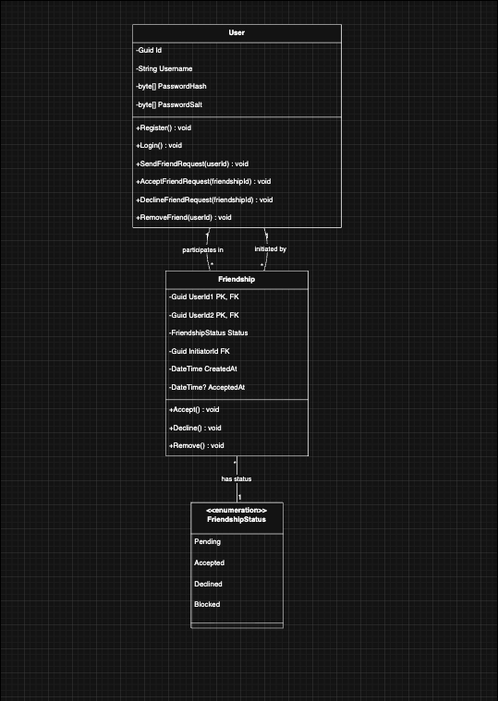

3.2 Behaviour Model (BPMN)

Process 1: Send Friend Request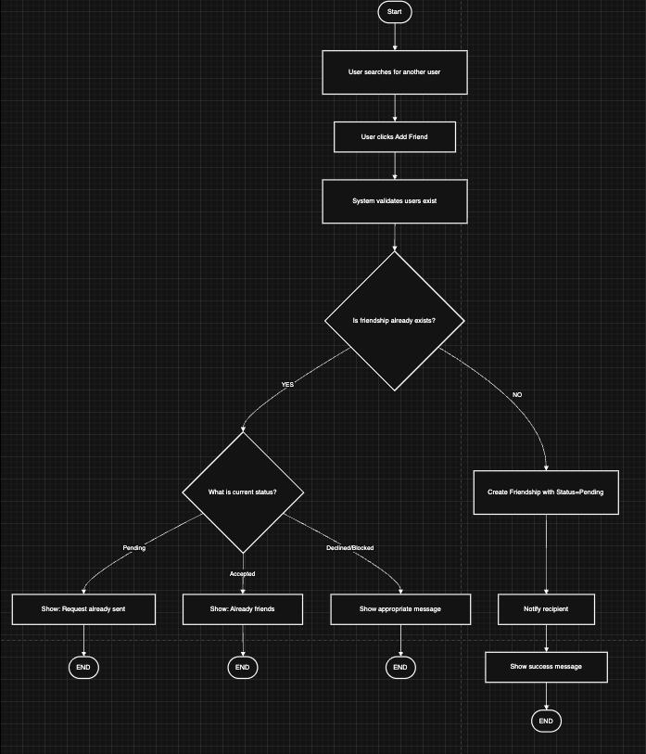

Process 2: Respond to Friend Request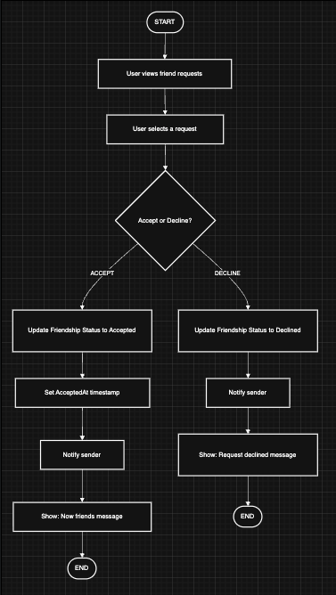

Process 3: Remove Friend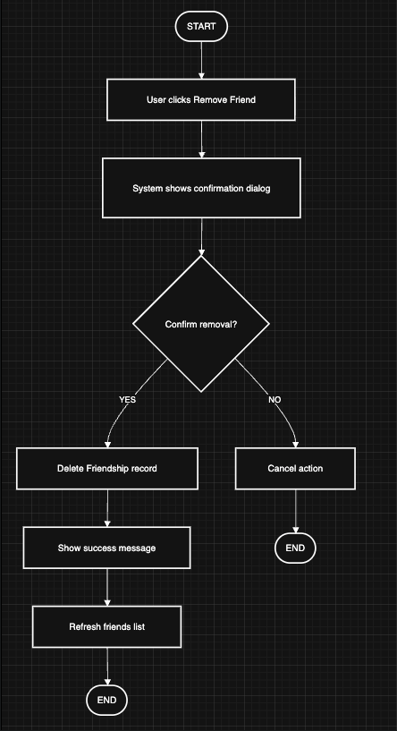

Process 4: Invite Friend to Playlist

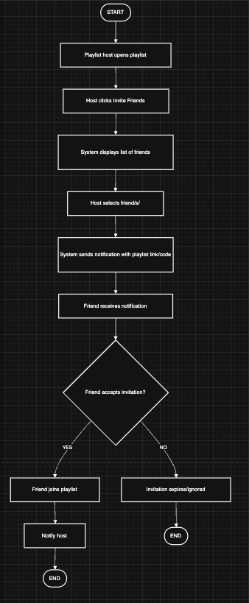

4. Requirements Validation

UC-01: Invite Friend

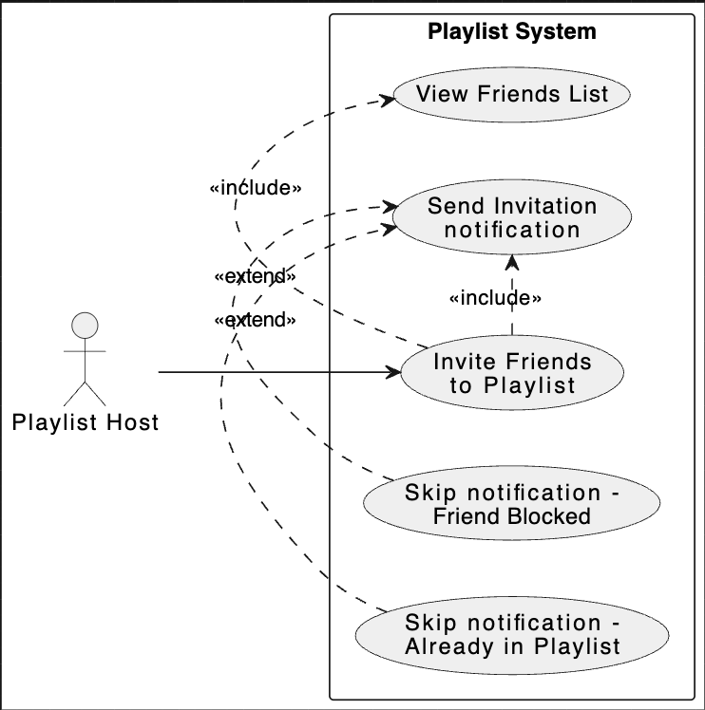

UC-02: Manage Sent Requests

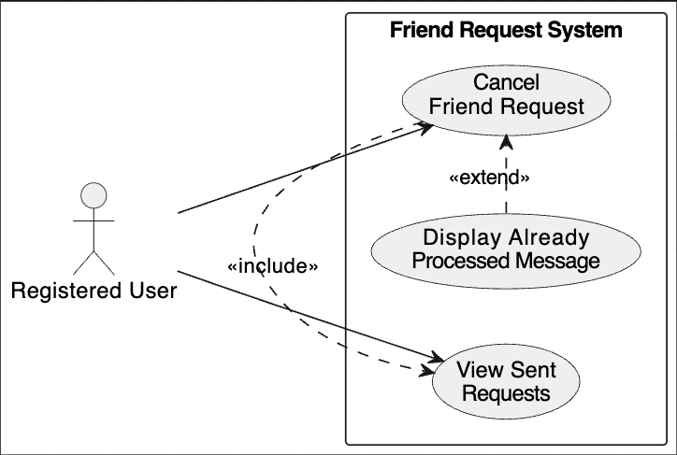

UC-03: Block User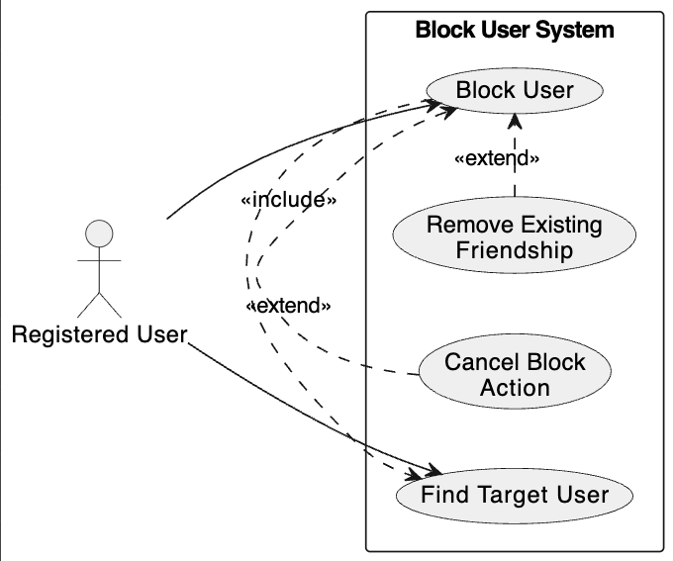

UC-04: View Friends in Current Session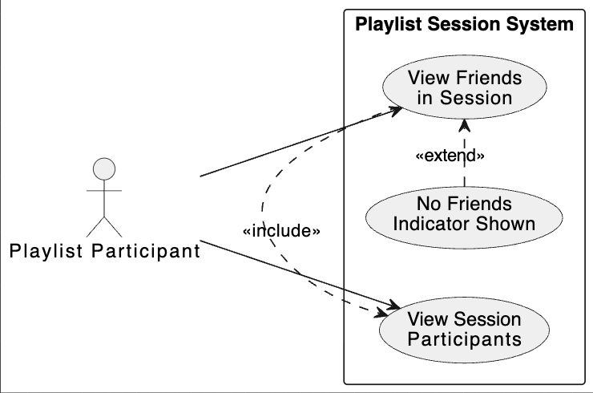

4.5 Assumptions and Constraints
Assumptions:
- Users have unique usernames for search ability
- PostgreSQL database can handle additional Friendship table
- Existing authentication system provides user identity in API calls
Constraints:
- Must integrate with existing .NET backend and React frontend
- Must use existing database schema patterns
- Must maintain backward compatibility with existing features
- Development limited to current team capacity
- Must follow existing code structure (Controllers, Services, Repositories, DTOs)

4.6 Risks and Mitigation
Risk | Impact | Mitigation
Spam friend requests | High | Implement rate limiting (NFR-15)
Privacy concerns | High | Privacy controls
Database schema conflicts | Medium | Careful migration planning, testing

5. Requirements

5.1 Functional Requirements

5.1.1 Friend Management
Req ID | Requirement | Priority | Source
FR-01 | The system SHALL allow authenticated users to search for other users by exact or partial username | High | N-USER-07
FR-02 | The system SHALL allow users to send friend requests to other users | High | N-USER-01
FR-03 | The system SHALL prevent users from sending friend requests to themselves | High | System integrity
FR-04 | The system SHALL prevent duplicate friend requests between the same two users | High | System integrity
FR-05 | The system SHALL allow users to view all received friend requests | High | N-USER-08
FR-06 | The system SHALL allow users to view all sent friend requests | Medium | N-USER-09
FR-07 | The system SHALL allow users to accept pending friend requests | High | N-USER-02
FR-08 | The system SHALL allow users to decline pending friend requests | High | N-USER-02
FR-09 | The system SHALL allow users to cancel their sent friend requests (status Pending) | Low | N-USER-09
FR-10 | The system SHALL allow users to remove existing friends (status Accepted) | Medium | N-USER-04
FR-11 | The system SHALL record the timestamp when a friendship is created | Medium | Analytics, auditing
FR-12 | The system SHALL record the timestamp when a friendship is accepted | Medium | Analytics, auditing
FR-13 | When a friendship status changes to Accepted, both users SHALL see each other in their friends list | High | N-USER-03

5.1.2 Friend Discovery and Viewing
Req ID | Requirement | Priority | Source
FR-14 | The system SHALL display a list of all friends (status Accepted) for the authenticated user | High | N-USER-03
FR-15 | The friends list SHALL display each friend's username | High | N-USER-03
FR-16 | The friends list SHALL indicate each friend's online status | Medium | N-USER-06
FR-17 | The friends list SHALL show if a friend is currently in an active playlist session | Medium | N-USER-06
FR-18 | The system SHALL allow users to view a friend's profile | Medium | N-USER-05
FR-19 | The friend profile view SHALL display all public playlists created by that friend | Medium | N-USER-05

5.1.3 Friend-Based Playlist Features
Req ID | Requirement | Priority | Source
FR-21 | The system SHALL allow playlist hosts to invite specific friends to their playlists | High | N-HOST-01
FR-22 | Invited friends SHALL receive in-app notifications with a direct link to the playlist | High | N-HOST-01
FR-23 | The system SHALL display which friends are currently in the same playlist session | Medium | N-HOST-02

5.1.4 Privacy and Blocking
Req ID | Requirement | Priority | Source
FR-24 | The system SHALL allow users to block other users | Medium | User safety
FR-25 | When a user blocks another, the system SHALL automatically remove any existing friendship | Medium | User safety
FR-26 | The system SHALL prevent blocked users from sending new friend requests to the blocker | High | User safety
FR-27 | The system SHALL hide the blocker's profile and playlists from blocked users | Medium | Privacy

5.2 Non-Functional Requirements

5.2.1 Performance
Req ID | Requirement | Priority | Rationale
NFR-01 | Friend search SHALL return results within 2 seconds for queries on username | High | User experience
NFR-02 | Friend request operations (send, accept, decline) SHALL complete within 1 second | High | Real-time feel

5.2.3 Usability
Req ID | Requirement | Priority | Rationale
NFR-03 | The friends list SHALL be accessible from the main navigation | High | Discoverability
NFR-04 | Friend-related notifications SHALL be clearly visible and distinguishable | High | User awareness
NFR-05 | Error messages SHALL clearly indicate why a friend operation failed | Medium | User guidance

5.2.4 Security
Req ID | Requirement | Priority | Rationale
NFR-06 | All friend operations SHALL require user authentication | High | Data privacy
NFR-07 | Users SHALL only access friendship data where they are one of the participants | High | Privacy protection
NFR-08 | Friend searches SHALL NOT expose email addresses or sensitive user data | High | Privacy protection
NFR-09 | The system SHALL rate-limit friend requests to 20 per user per hour | Medium | Prevent spam

